Assignment - 02
UX Research Artifacts (BharatMatrimony)

1. Empathy Map
Empathy map for a parent creating and managing a matrimonial profile on behalf of her adult son through BharatMatrimony (www.bharatmatrimony.com), a role the site itself accommodates via its ‘Profile created for: Myself / Daughter / Son / Sister / Brother / Relative / Friend’ option on the registration form.

SAYS | THINKS
"I don’t want a modelling profile for him — I want something simple and honest that shows he’s a good, settled boy."  "Why is it asking me if the profile is for myself, my son, my daughter— will they know I’m his mother when they call?"  "Can I see the boy’s side... I mean, can other families see his photo before we see theirs?"  "Do we have to pay before we can even talk to anyone, or can we try for free first?" | Will I fill something wrong in his profile and he’ll be upset with me later?  Is it safe to put his phone number and photo on a website like this?  If I pay for Gold membership and it doesn’t work out in three months, was that money wasted?  What is this 'gothra' and 'subcaste' field really used for, and who can see it?
DOES | FEELS
Selects ‘Profile created for’ → Son on the homepage registration widget, then enters his name, gender, and her own mobile number for the OTP.  Uses Advanced Search (with subcaste & gothra filters) to narrow results the way she and her husband discussed for their community.  Uploads a photo and starts the horoscope form, then waits, unsure how long ‘validation’ will take before it is visible to others.  Calls the 24x7 helpline number listed in the header when she is unsure whether her son’s mobile number has been verified correctly. | Nervous about representing her son accurately without his day-to-day input.  Reassured by the “100% mobile-verified profiles” and Trust Badge messaging, though not fully sure what it guarantees.  Overwhelmed by the number of membership tiers and add-ons when she reaches the payment page.  Hopeful when she sees the success-story carousel on the homepage, but cautious about committing money before seeing real responses.

2. Pain Points
Pain points below are drawn from direct interaction with the live registration, search, payment, and locator pages, together with details documented in BharatMatrimony's own FAQ (validation timelines, membership benefits, password rules, deletion policy, auto-renewal).
- The homepage registration widget asks whether the profile is for ‘Myself, Daughter, Son, Sister, Brother, Relative, Friend’ but gives no explanation of how a parent-created profile is labelled or verified differently from a self-created one, leaving a parent unsure how the account will represent her son.
- Photo and horoscope uploads go through a manual validation step (per the FAQ, typically within 1–24 hours) with no visible in-progress status on the profile itself, so a user cannot tell whether an upload is pending, rejected, or simply slow.
- What a free member can and cannot do — no phone numbers, no chat, no personalised messages, only template ‘Express Interest’ — is documented only in the FAQ rather than shown at the point of registration or search, so the paywall is discovered by hitting it rather than being told upfront.
- The payment/upgrade page presents five membership tiers (Gold, Diamond, Platinum, Till-U-Marry, Assisted Service) across three durations, plus separate add-ons (Profile Highlighter, AstroMatch, Matrimony Booster), with no default or ‘recommended’ option, which is a heavy decision load for a first-time buyer.
- Advanced Search exposes community-specific fields (subcaste, gothra) without any visible explanation of who can see these fields or how they are used in matching, which can feel opaque for a user cautious about privacy.
- The account password is capped at a maximum of 8 characters (per the FAQ), and a forgotten photo/horoscope protection password “cannot be retrieved,” only reset — both reduce confidence in account and content security.
- The site states different “years in operation” figures on different pages (26 years on the homepage banner, 23 years on the registration page, 24 years in the FAQ footer), which is a small but noticeable inconsistency for a brand whose main pitch is trust and longevity.
- The retail-outlet locator (used by less digitally confident family members who prefer visiting a branch) shows apparent data inconsistencies — repeated entries and city links grouped under seemingly unrelated states — that could make it hard to find the correct nearest branch.
- No visible on-page accessibility controls (contrast or text-size adjustment) were found on the pages reviewed, and several functional icons carry generic, non-descriptive alt text, which is a barrier for a less tech-comfortable or older family member helping with the profile.
- Auto-renewal is enabled by default for international members (opt-out only after a reminder email, per the FAQ), which could catch a family member off guard if they assumed the membership would simply lapse at the end of the paid term.

3. Persona
Meera Deshpande, 54
Homemaker and former schoolteacher, Pune, Maharashtra
Background / Life Context: Meera's son, 29, works long hours as a software engineer and has little time or inclination to search matrimonial sites himself. Meera and her husband have taken on the search on his behalf, as is common practice in their extended family, and chose BharatMatrimony because relatives described it as the most established and trustworthy option for their community.
Technology Comfort: Moderate. Comfortable with WhatsApp, UPI payments, and basic web browsing, but relies on her son or the helpline for anything unfamiliar, such as uploading a horoscope file or understanding a payment page.

Goals
- Create an honest, complete profile for her son (photo, horoscope, education, family background) without needing his constant input.
- Understand exactly what she gets for free versus what requires payment before recommending a membership tier to her husband.
- Find genuinely compatible families from their own community using the caste/subcaste/gothra filters they consider important.
- Be confident that her son's phone number and photo are only shown to serious, verified members.

Frustrations
- Not knowing how long photo/horoscope validation will take, or whether it succeeded, without calling the helpline.
- Discovering mid-search that she cannot view a match's phone number or start a chat without upgrading to a paid tier.
- Facing five membership tiers and three add-ons at the payment page with no guidance on which one suits a first-time family.
- Worrying that a mistake in her son's profile (wrong caste/subcaste field, unclear horoscope entry) cannot be easily corrected — the FAQ notes some fields, like age, can only be edited once.

Needs
- Clear, upfront confirmation that an upload (photo/horoscope) has been received and is pending validation.
- A plain-language summary of free vs paid features shown before or during registration, not only in the FAQ.
- A simple explanation of how community-specific search fields (subcaste, gothra) are used and who can see them.
- Reassurance — through the retail outlet or the 24x7 helpline — that a human can help if something goes wrong online.

Behaviours
- Prefers to do the initial registration and searching herself, then involves her son for photo selection and final approval before anything is made visible.
- Cross-checks information by calling the helpline number rather than relying solely on the FAQ, especially for anything involving payment.
- Uses the Advanced Search filters for subcaste and gothra methodically, the way her family has always screened prospects offline.
- Reads the success-story carousel on the homepage as social proof before deciding whether to trust the platform with a paid membership.

Motivations
- A sense of parental duty to actively help find a suitable match for her son, who she feels is “too busy with work” to search himself.
- Trust in BharatMatrimony as a long-established, government-adjacent-feeling, “most trusted” brand rather than a newer app.
- A wish to combine traditional community-based matching (caste, subcaste, gothra, horoscope) with the reach of an online platform.
- Financial caution — she wants to see genuine interest and responses before committing to a higher-tier paid membership.

Decision Factors
- Whether the free tier produces any real responses before she recommends paying for Gold/Diamond/Platinum.
- How clearly the site explains what a paid membership actually unlocks (phone numbers, chat, personalised messages).
- Whether her son's photo and contact details feel adequately protected (Trust Badge, photo password, verified-mobile claims).
- Availability of a nearby retail outlet or helpline in case something needs sorting out in person.

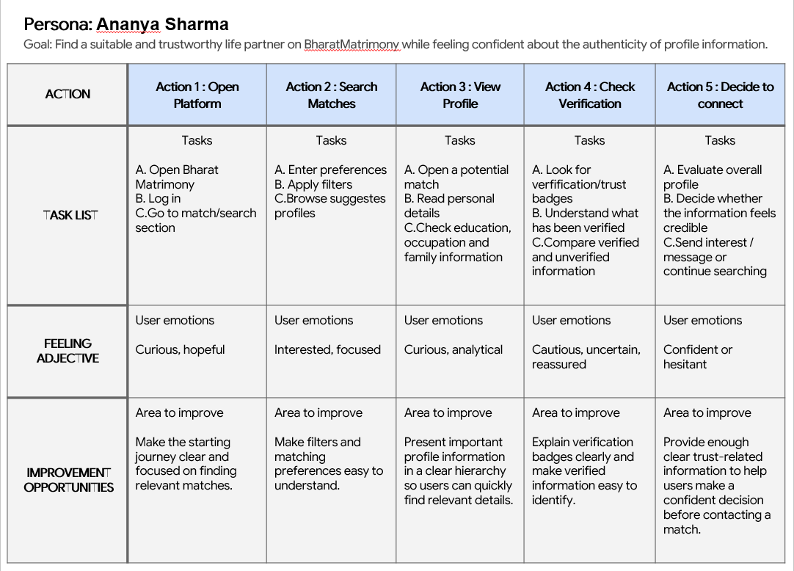

4. User Journey Map
Meera's end-to-end journey creating, running, and eventually pausing her son's profile on BharatMatrimony.
Stage | Actions | Thoughts | Pain Points | Opportunities
Awareness | Hears from relatives and sees the BharatMatrimony TV commercial that it is the largest, most trusted matrimony brand; decides to create a profile for her son. | “Everyone says this is the reliable one — let's try it before anything else.” | No independent way to verify the site's trust claims (years/customers) beyond its own marketing. | Provide a single, consistently-stated set of trust statistics site-wide to reinforce (not undermine) first impressions.
Registration | On the homepage, selects ‘Profile created for → Son’, enters his name, gender, and her own mobile number to receive the OTP. | “I hope the OTP comes to my phone properly and I don't get stuck here.” | No explanation of how a parent-created profile differs from a self-created one, or what her son will see/approve later. | Add a short explainer step clarifying how relative-created profiles are labelled, verified, and eventually handed over or approved by the actual candidate.
Profile Building | Fills in education, family background and profile description (guided by the FAQ's sample description), uploads a photo, and starts the horoscope form. | “Is this description too long? Will people even read all this?” | No visible status indicator for photo/horoscope validation once submitted. | Show a clear ‘pending validation’ badge on the profile with an expected turnaround time.
Search & Shortlisting | Uses Advanced Search with subcaste and gothra filters, switches between Regular and Prime results, and shortlists a few profiles with comments. | “These Prime profiles look more complete — are they simply the paid ones, or actually better matches?” | No visible explanation of how Prime differs from Regular beyond ‘verified, high-quality profiles with photos’. | Add a short tooltip or FAQ link next to the Prime/Regular toggle explaining exactly what changes in the results.
Contact & Upgrade | Sends free Express Interest messages to a few shortlisted families, then reaches the payment page to consider Gold/Diamond/Platinum after interests are accepted. | “Which package do we actually need just to talk properly with these families?” | Five tiers × three durations plus three separate add-ons, with no recommended default for a first-time buyer. | Highlight one tier as ‘Recommended for first-time members’ and show a plain ‘what you get for free vs. paid’ comparison before the pricing grid.
Ongoing Management | Checks MatchWatch emails and the My Home dashboard for new matches and interest responses; occasionally calls the helpline with questions. | “Did that family see our interest, or has it gone into some filtered folder?” | Login-gated status (filtered messages, mutual matches) is only documented in the FAQ, not previewed for a new member. | Send a short onboarding email or in-app tour after registration explaining where responses, filters, and mutual matches will appear.
Cancellation / Profile Closure | If her son gets engaged through another route or the family wants to pause the search, she looks for how to deactivate or delete the profile. | “I just want to pause this, not lose everything if we need it again later.” | The FAQ states a deleted profile “cannot be restored or reactivated under any circumstance”; deactivation and deletion are not clearly distinguished on the profile-settings entry point. | Make the difference between ‘Deactivate’ (reversible) and ‘Delete’ (permanent) visually distinct, with a confirmation step that restates the consequence.

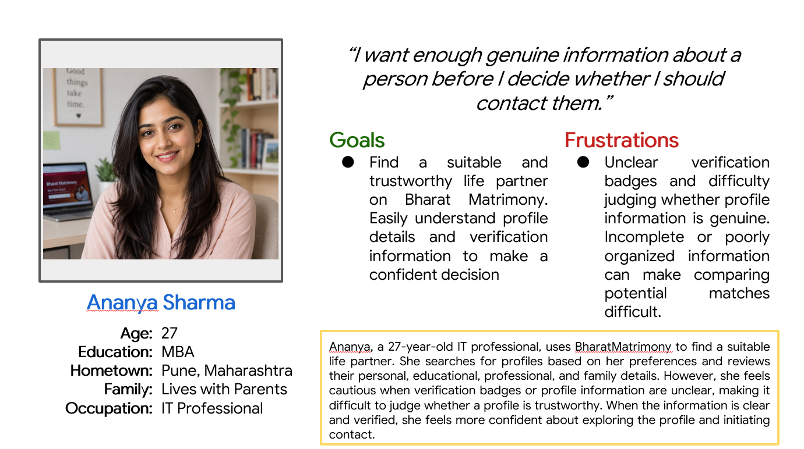

5. Gaps for Future Improvement
Each opportunity below is traceable to a specific pain point, empathy-map insight, or journey stage identified earlier in this document.
- Add a short explainer at the ‘Profile created for’ step clarifying how relative-created profiles are labelled and eventually confirmed by the actual candidate (traces to Empathy Map – THINKS, and Journey – Registration).
- Show a visible ‘pending validation’ status on photos and horoscopes with an expected turnaround time instead of leaving the user to guess (traces to Pain Point 2 and Journey – Profile Building).
- Surface a plain-language free-vs-paid feature comparison at registration or in search results, not only inside the FAQ (traces to Pain Point 3 and Journey – Contact & Upgrade).
- Highlight one membership tier as a ‘Recommended’ default on the payment page to reduce first-time decision fatigue across five tiers and three durations (traces to Pain Point 4 and Persona – Frustrations).
- Explain, in plain language near the Advanced Search filters, how subcaste/gothra fields are used and who can view them (traces to Pain Point 5 and Empathy Map – SAYS).
- Strengthen account security: raise the password length cap and offer a supervised recovery path for a forgotten photo/horoscope password instead of an unexplained hard reset (traces to Pain Point 6).
- Standardise the ‘years in operation’ and customer-count figures across every page to protect the brand's core trust pitch (traces to Pain Point 7 and Journey – Awareness).
- Audit and correct the retail-outlet locator's city/state groupings and duplicate entries so family members who prefer an in-person visit can find the right branch (traces to Pain Point 8 and Persona – Needs).
- Add basic accessibility controls (contrast, text size) and descriptive alt text on functional icons to support less tech-comfortable users helping with a profile (traces to Pain Point 9 and Empathy Map – FEELS).
- Make international auto-renewal an explicit opt-in at purchase, and visually separate ‘Deactivate’ from the irreversible ‘Delete’ action with a restated consequence at confirmation (traces to Pain Point 10 and Journey – Cancellation / Profile Closure).

Note on Sources
The interface details referenced throughout — the ‘Profile created for’ options, Advanced Search's subcaste/gothra fields, the Regular/Prime toggle, the five-tier membership and add-on structure on the payment page, the FAQ's stated validation timelines, password rules, deletion policy, and auto-renewal terms, and the retail-outlet locator's content — were observed directly on the live site. General context about how Indian families commonly conduct parent-led matchmaking searches (reflected in the persona's background and motivations) draws on widely documented, publicly known norms around arranged-marriage platforms in India rather than a claim verified on this specific site. Meera Deshpande is an illustrative persona constructed to fit a realistic and common user pattern this site's own registration options support; she is not a real individual. Any behaviour that requires an active, paid, logged-in account — actual match responses, the My Home dashboard, live chat, and the final payment-confirmation screen — could not be exercised directly and is presented as a reasonable inference from the FAQ and payment-page content rather than as independently verified fact.

